Example on downloading WP76 yocto source from Github

Procedure
- If you do not have a GitHub account, you will need to create one for free at https://github.com/join
- Setup git configuration
e.g. assume you have a git account with username@gmail.com
git config --global user.name "username"
git config --global user.email "username@gmail.com"

- Created ECDSA keys for your linux development machine
ssh-keygen -t ecdsa -b 521 -C “username@gmail.com”

(Remember the passphrase, as you will need it to unlock the key whenever you use it. )

- Open ~/.ssh/id_ecdsa.pub and register the SSH key in https://github.com/settings/keys
e.g.
cat /home/owner/.ssh/id_ecdsa.pub
copy the value to https://github.com/settings/keys
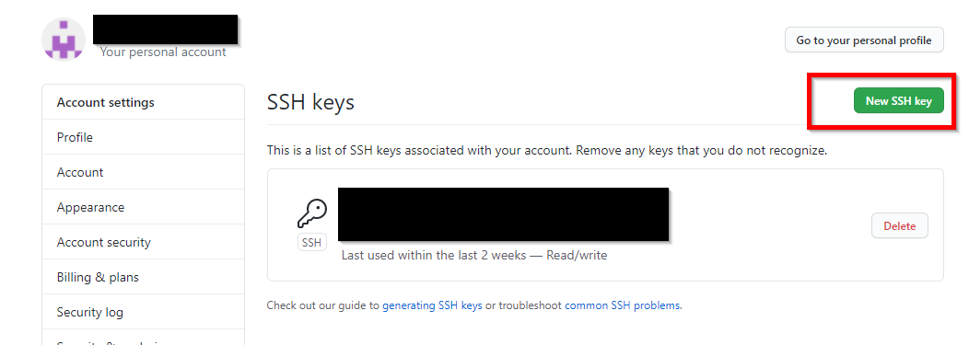

- Set up permission for the keys.
e.g.
sudo chmod 700 ~/.ssh/
sudo chmod 600 ~/.ssh/*
sudo chown -R owner ~/.ssh/
sudo chgrp -R owner ~/.ssh/

(where owner is the username of my PC)

- To make it possible for your account to access private repositories, go to https://swi-license.legato.io. Follow the instructions, and if you choose to accept the license, your GitHub user will be placed in the legato project organization. You can check that access was granted successfully by accessing https://github.com/legatoproject/test-access/
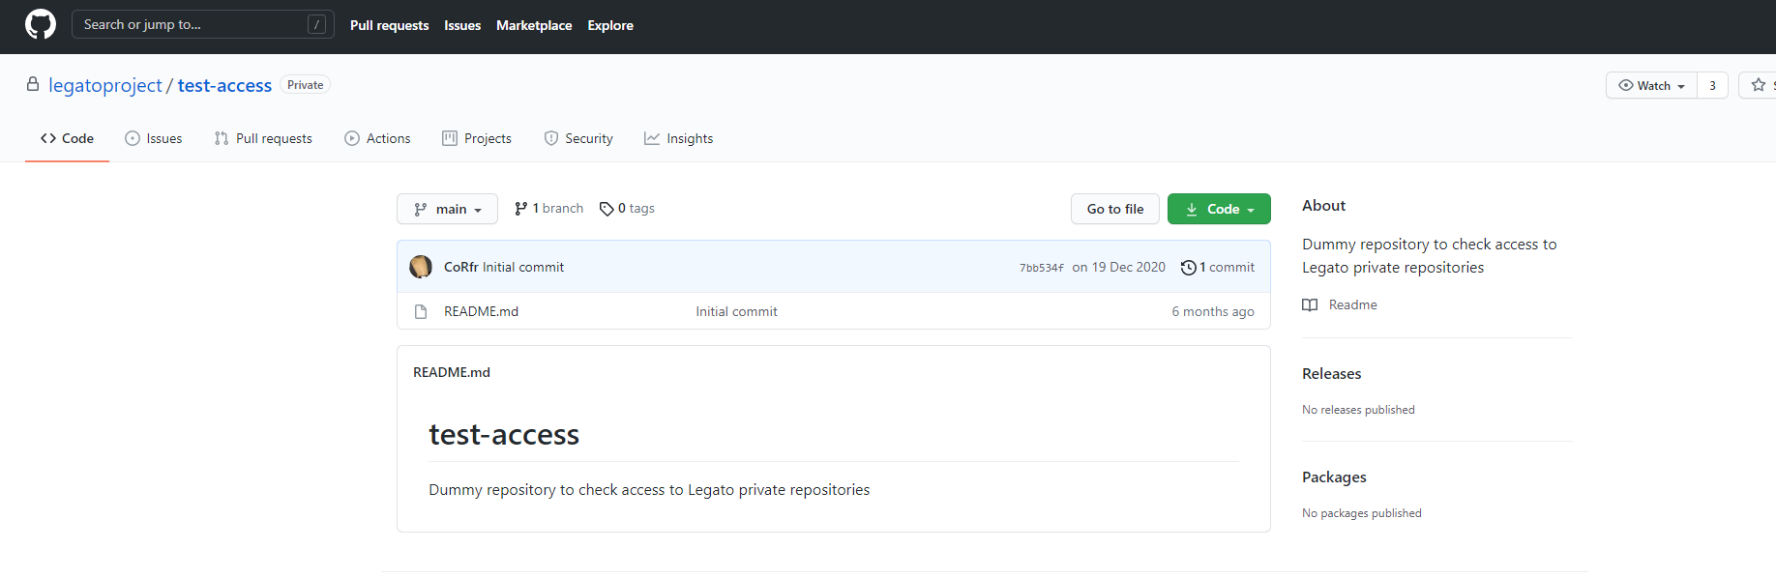

- Install git and repo tool
sudo apt-get install git
sudo apt-get install repo

For Ubuntu 14, repo cannot be installed.
We need to manually do this and install python 3.6:

curl https://storage.googleapis.com/git-repo-downloads/repo -o repo
chmod a+x repo
sudo add-apt-repository ppa:deadsnakes/ppa
sudo apt update
sudo apt install python3.6
sudo rm /usr/bin/python3
sudo ln -s /usr/bin/python3.6 /usr/bin/python3

- Now download the WP76 yocto source (R16 in this example) from Github.
repo init -u ssh://git@github.com/legatoproject/manifest -m products/wp76xx/releases/Release16.xml -g default,-cache,proprietary
repo sync

For Ubuntu 14, you need to enter following to download yocto source.
python3 repo init -u ssh://git@github.com/legatoproject/manifest -m products/wp76xx/releases/Release16.xml -g default,-cache,proprietary
python3 repo sync

Reference
- https://docs.legato.io/latest/toolsGitHub.html
- https://issues.sierrawireless.com/browse/MOLWP9X07-952
- https://stackoverflow.com/questions/71500791/eclipse-git-youre-using-an-rsa-key-with-sha-1-which-is-no-longer-allowed-pl

