Device was not communicating with back-office system. While the device was turned on, jumped into the cab and got this error message when trying to connect.

Grabbed Watcher.txt file and Watcher logs. Every time trying to connect, it would give the same message. Interestingly, when I went into the ‘Networking’ tab, it flashed up the options for using 2G only, before reverting back to ‘Automatic’ (is it stuck on 2G?)
Closed and re-opened Sierra. Got the following message straight away (without trying to connect).
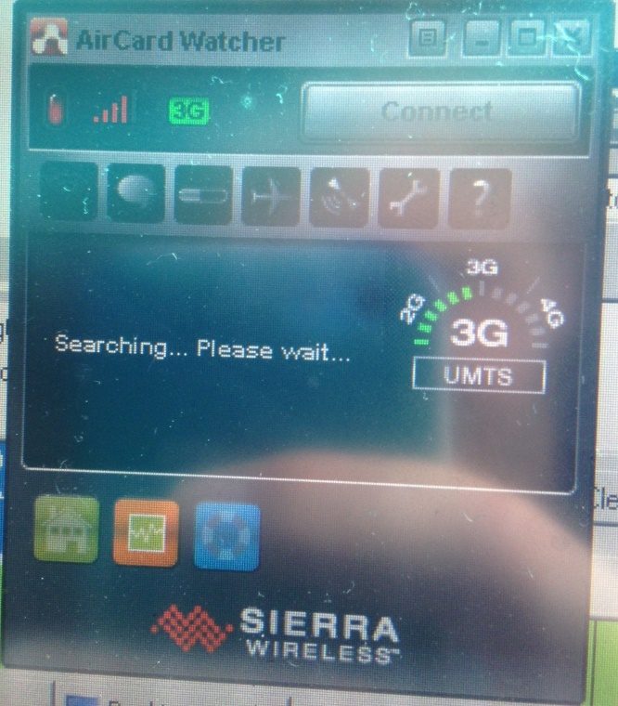
Ping request gave the following:
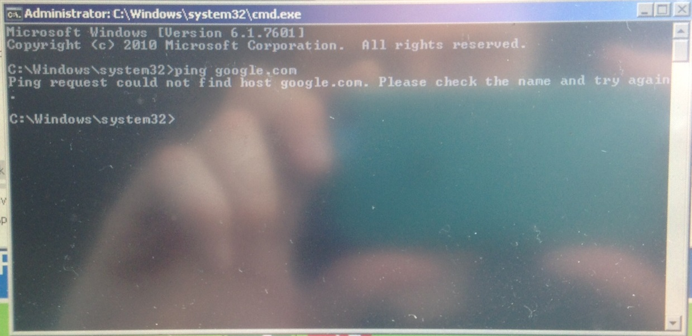
Tried stopping and starting both of the Watcher services (both individually and together) and reloading Watcher. Made no difference.

Results of AT commands shown below:

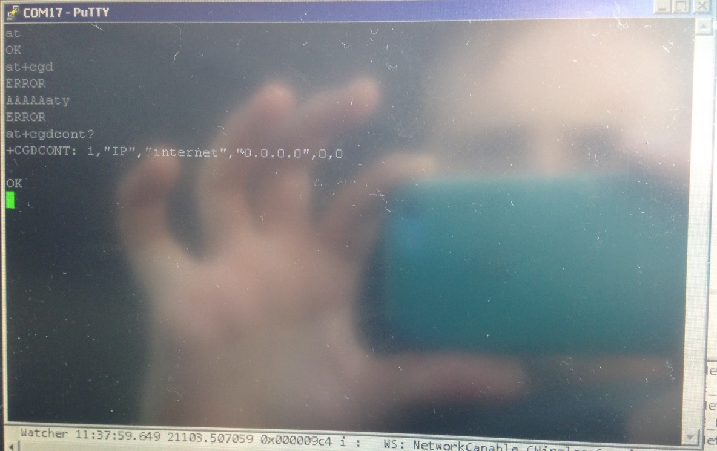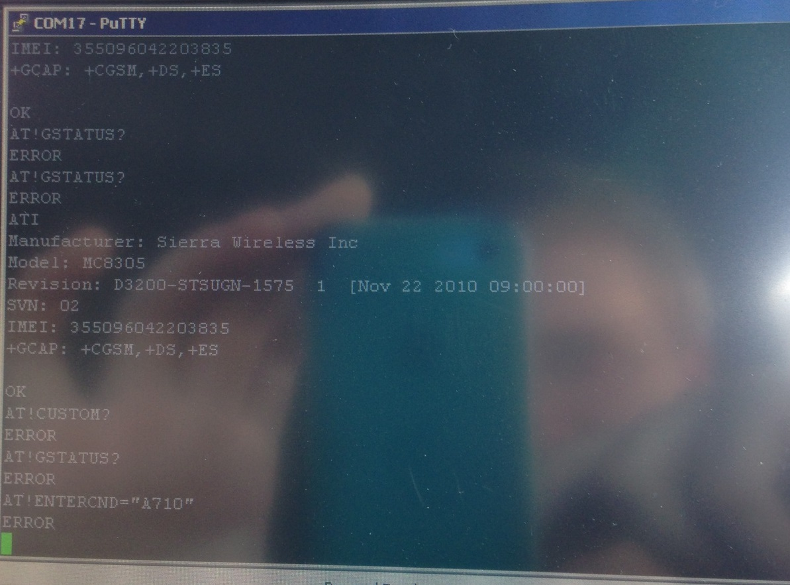

The following actions made no difference to Watcher’s behaviour: log off, restart, shut down. The only action to bring Watcher back to normal function was to shut down and take out the power lead then plug in and turn on, after which Watcher connected fine.

Note that the option has been chosen for Windows (in device manager) to not shut down the modem to save battery.

