To enter Recovery mode:
- Use an Ethernet cable to connect the gateway to your computer. (Recovery mode is
not supported on USBnet.)
- Press “Reset” button over 7-10s. (Release the button when the Power LED flashes amber.)
- Launch your browser and enter the IP address and port number
http://192.168.13.31:9191 or https://192.168.13.31:9443, you will enter to Recovery mode as below:
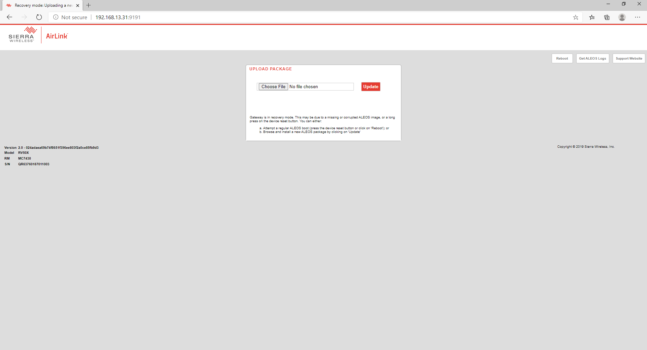
- Choose Aleos firmware -> press Update
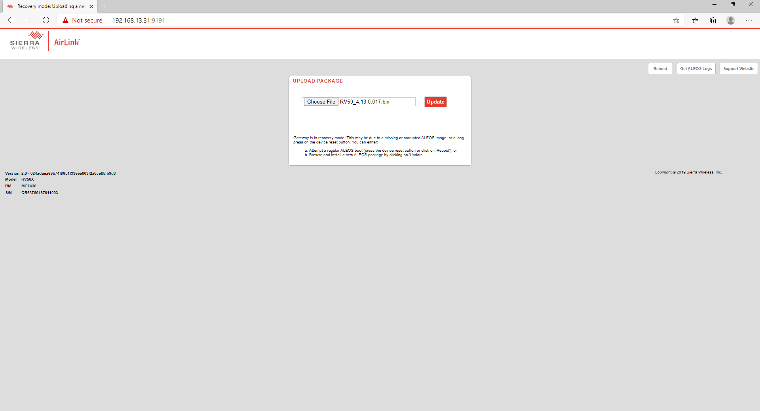

- Wait for firmware installing
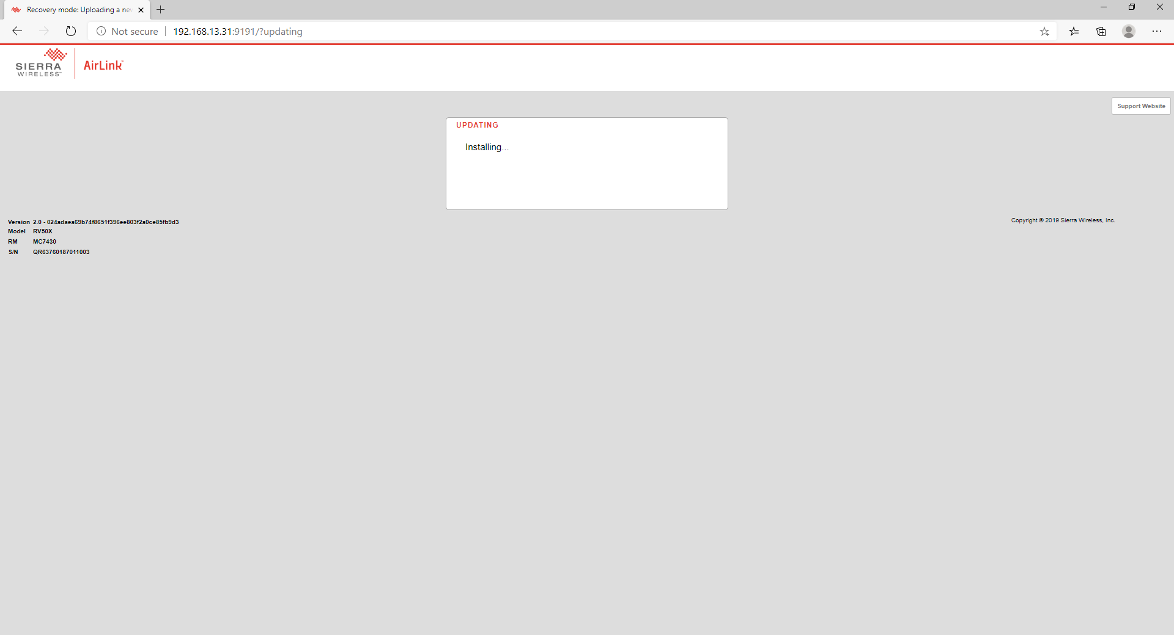
- After a minute, the screen is as below, press Reboot
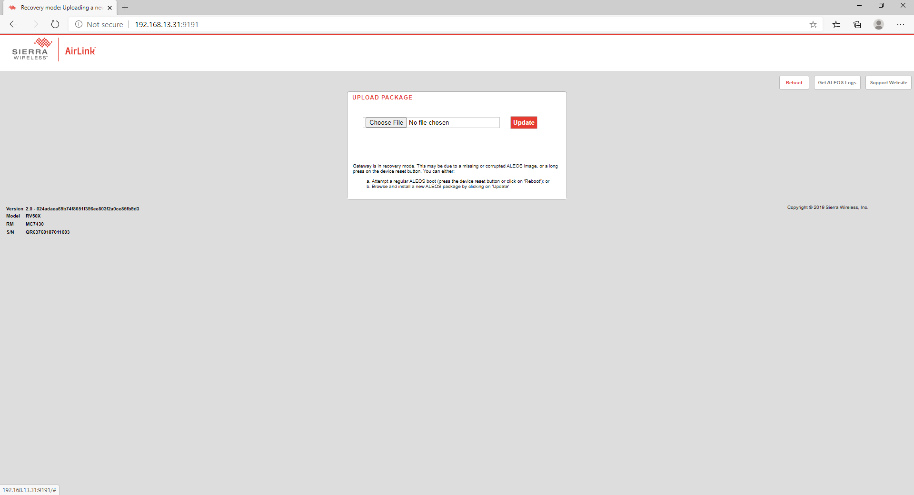

- Wait device is rebooted, select Software and Firmware, and upgrade Radio firmware again.

