Enable remote trace levels to capture the traces. Go to **“Remote traces”** tab of trace configuration and check the box to use firmware package. Include the remote trace file.

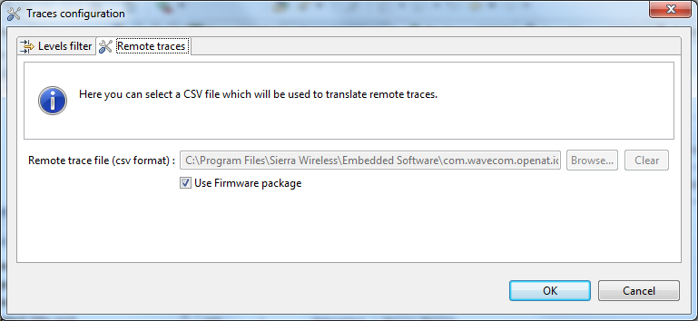

For latest version of Developer studio (2.2.1).Go to “**Advanced”** tab of trace configuration and check the box to use firmware package. Include the remote trace file.

