How to make WP76 module as mass storage device

Procedure
- The test below is verified on MangOH Green WP7608 module FW R12 with official released image.
- Transfer the following busybox to module /home/root directory by SCP
- Create an empty 32MB FAT image (in /tmp/fat.fs) using mkdosfs command

chmod 777 ./busybox-armv5l_1.26
dd if=/dev/zero of=/tmp/fat.fs bs=1024 count=32768
./busybox-armv5l_1.26 mkdosfs /tmp/fat.fs

- Mount this FAT image in “/tmp/mass_storage” in order to add some files
mkdir /tmp/mass_storage
mount -o loop /tmp/fat.fs /tmp/mass_storage
echo "Hello World!" > /tmp/mass_storage/README.TXT

- Add “mass_storage” in the USB functions
echo 0 > /sys/class/android_usb/android0/enable
echo diag,serial,rmnet,ecm,mass_storage > /sys/class/android_usb/android0/functions
echo /tmp/fat.fs > /sys/class/android_usb/android0/f_mass_storage/lun/file
echo 1 > /sys/class/android_usb/android0/enable

- You will then see the mass storage folder on PC.
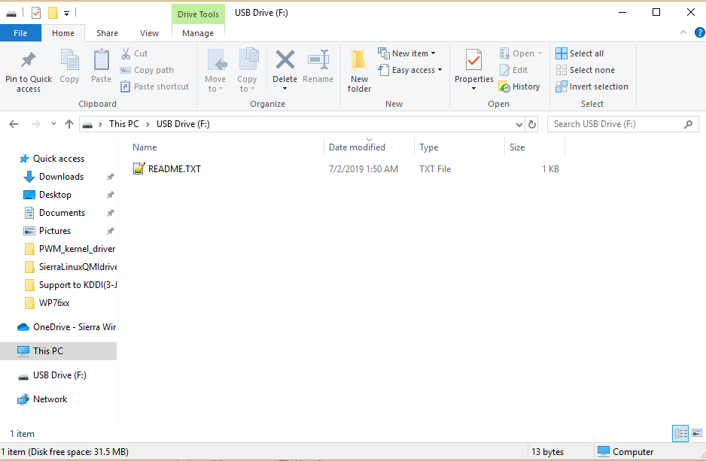

Reference
https://forum.legato.io/t/making-wp7607-appear-as-mass-storage-device/4453/4

